|  |  |
| --- | --- |
| **Grade:** | X / 100 |
| **Instructor’s Comments:** | To be filled by the instructor |

This lab template is developed per data collection requirement for ABET accreditation process. Your cooperation of using it is highly appreciated. ***Please do not delete this page!***

**Grading Criteria**:

Each lab is worth 100 points. The first 20 points are toward your submission of required documents, and the rest 80 points are for the problem of each lab assignment.

|  |  |  |
| --- | --- | --- |
| **Item** | **Description** | **Points** |
| Required documents | 1) The lab report (this document)  **2) Any source code files (Don’t forget to compress them into a “.zip” file!)** | 20 |
| For all exercises/problems | Completeness of your work  1) Complete solution  2) Inclusion of screenshot of executing your code – you must include at least one whether your code works or not (if applicable)  Correctness of your logic/solution  Coding style (below are common mistakes)  1) Proper alignment of your code  2) Proper naming convention  3) Meaningful naming | 80 |

**ITS 330 – Advanced Operating Systems**

**Lab 05**

**Due: March 4th, 2021**

**Laquon Hamilton**

(***Create a table of contents before your solution***)

Contents

Problem 1. 3

Problem 2. 9

Problem 3. 9

Problem 4. 10

Problem 5. 10

Problem 6. 10

Problem 7. 10

Problem 8. 10

Problem 9. 11

# Problem 1. (5.1, 5.2)

Code:

Part 1

/*

 ITS-330

 Lab 05

 Problem 1 (5.1)

 3/3/2021

 Laquon Hamilton

*/

public interface Runnable

{

  public abstract void run();

}

Part 2

/*

 ITS-330

 Lab 05

 Problem 1 (5.1, 5.2)

 3/3/2021

 Laquon Hamilton

*/

public class PrintThread implements Runnable, java.lang.Runnable

{

  private char newElement;

  private int limit;

  public PrintThread(char c, int t)

  {

    newElement = c;

    limit = t;

  }

  public void run()

  {

    int num = 0; //for confirming how many times the element is printed

    for (int i = 0; i < limit; i++)

    {

      num++;

      System.out.print(" " + newElement);

      System.out.print("(" + num + ")");

    }

  }

}

Part 3

/*

 ITS-330

 Lab 05

 Problem 1 (5.1, 5.2)

 3/3/2021

 Laquon Hamilton

*/

import java.lang.Thread;

public class ThreadDemo

{

  public static void main(String[] args)

  {

    // TODO Auto-generated method stub

    java.lang.Runnable printA = new PrintThread('A', 100);

    Thread thread1 = new Thread(printA);

    System.out.println("\nThread 1:\n");

    thread1.start();

    while(thread1.isAlive())

    {

      //waits until previous thread is finished to execute the next thread

    }

    java.lang.Runnable printB = new PrintThread('B', 100);

    Thread thread2 = new Thread(printB);

    System.out.println("\n\nThread 2:\n");

    thread2.start();

    while(thread2.isAlive())

    {

      //waits until previous thread is finished to execute the next thread

    }

    java.lang.Runnable printNums = new PrintThread('\0', 100);

    Thread thread3 = new Thread(printNums);

    System.out.println("\n\nThread 3:\n");

    thread3.start();

  }

}

Screenshot

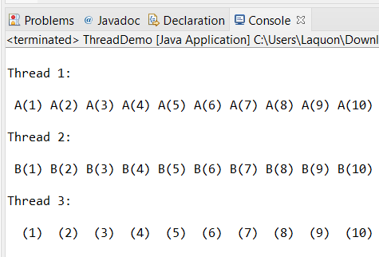

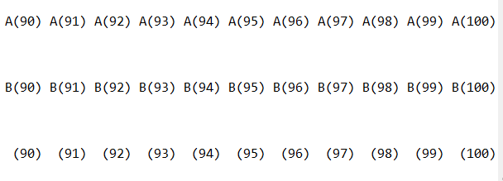

# Problem 2.

Code

Screenshot

# Problem 3.

Code:

Screenshot

# Problem 4.

Code

Screenshot

# Problem 5.

Code

Screenshot

# Problem 6.

Code

Screenshot

# Problem 7.

Code

Screenshot

# Problem 8.

Code

Screenshot

# Problem 9.

Code

Screenshot